TASK-1 FOR DEVOPS

- Installation for Java is required for Jenkins
Command
sudo apt update
sudo apt install fontconfig openjdk-17-jre
java -version
openjdk version "17.0.13" 2024-10-15
OpenJDK Runtime Environment (build 17.0.13+11-Debian-2)
OpenJDK 64-Bit Server VM (build 17.0.13+11-Debian-2, mixed mode, sharing)
Screeenshot :
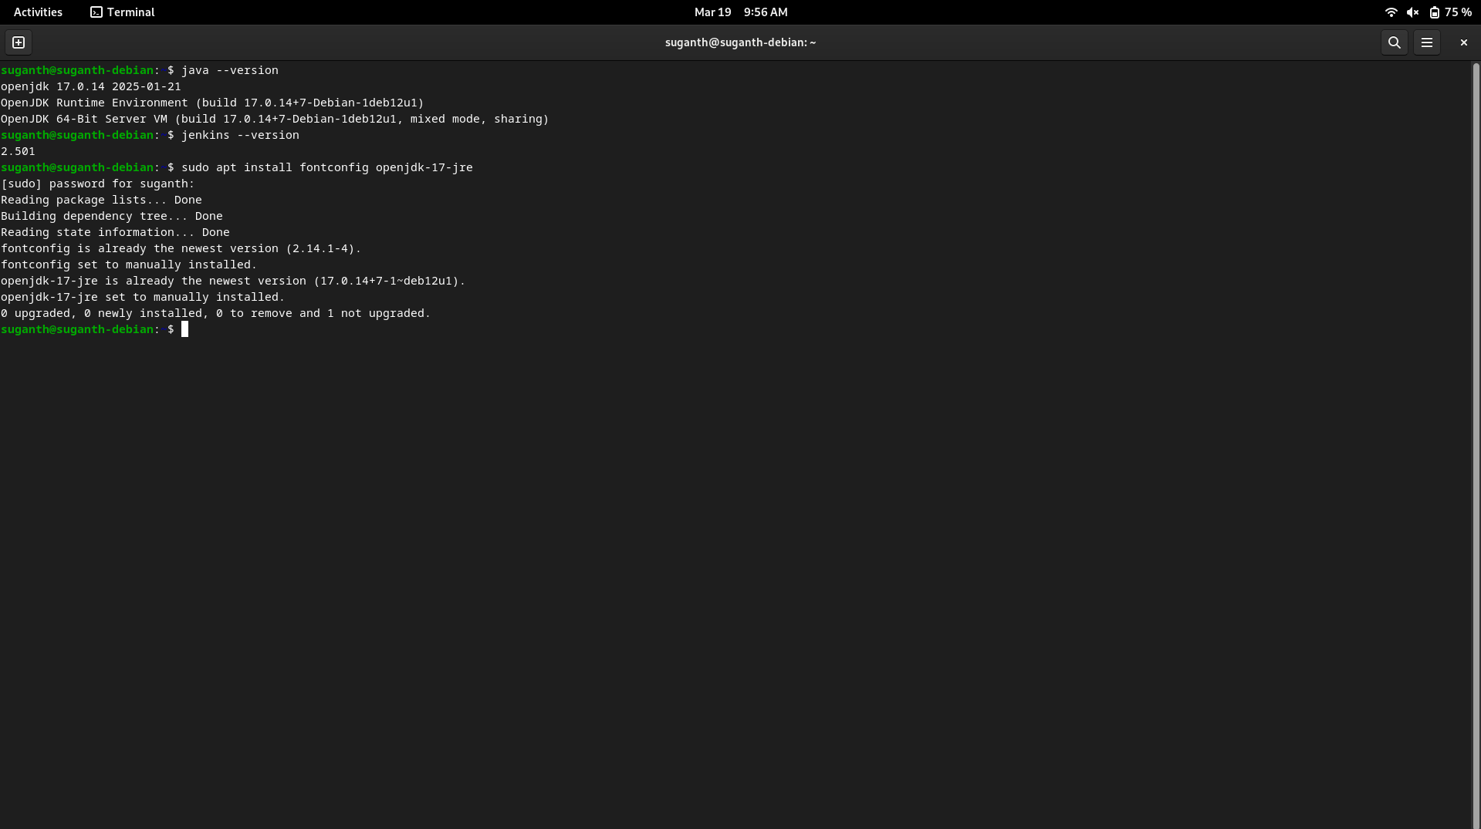
The Java JDK has been successfully installed.

- Install Jenkins

Command :
sudo wget -O /usr/share/keyrings/jenkins-keyring.asc \
https://pkg.jenkins.io/debian-stable/jenkins.io-2023.key
echo "deb [signed-by=/usr/share/keyrings/jenkins-keyring.asc]" \
https://pkg.jenkins.io/debian-stable binary/ | sudo tee \
/etc/apt/sources.list.d/jenkins.list > /dev/null
sudo apt-get update
sudo apt-get install jenkins

Screenshot :
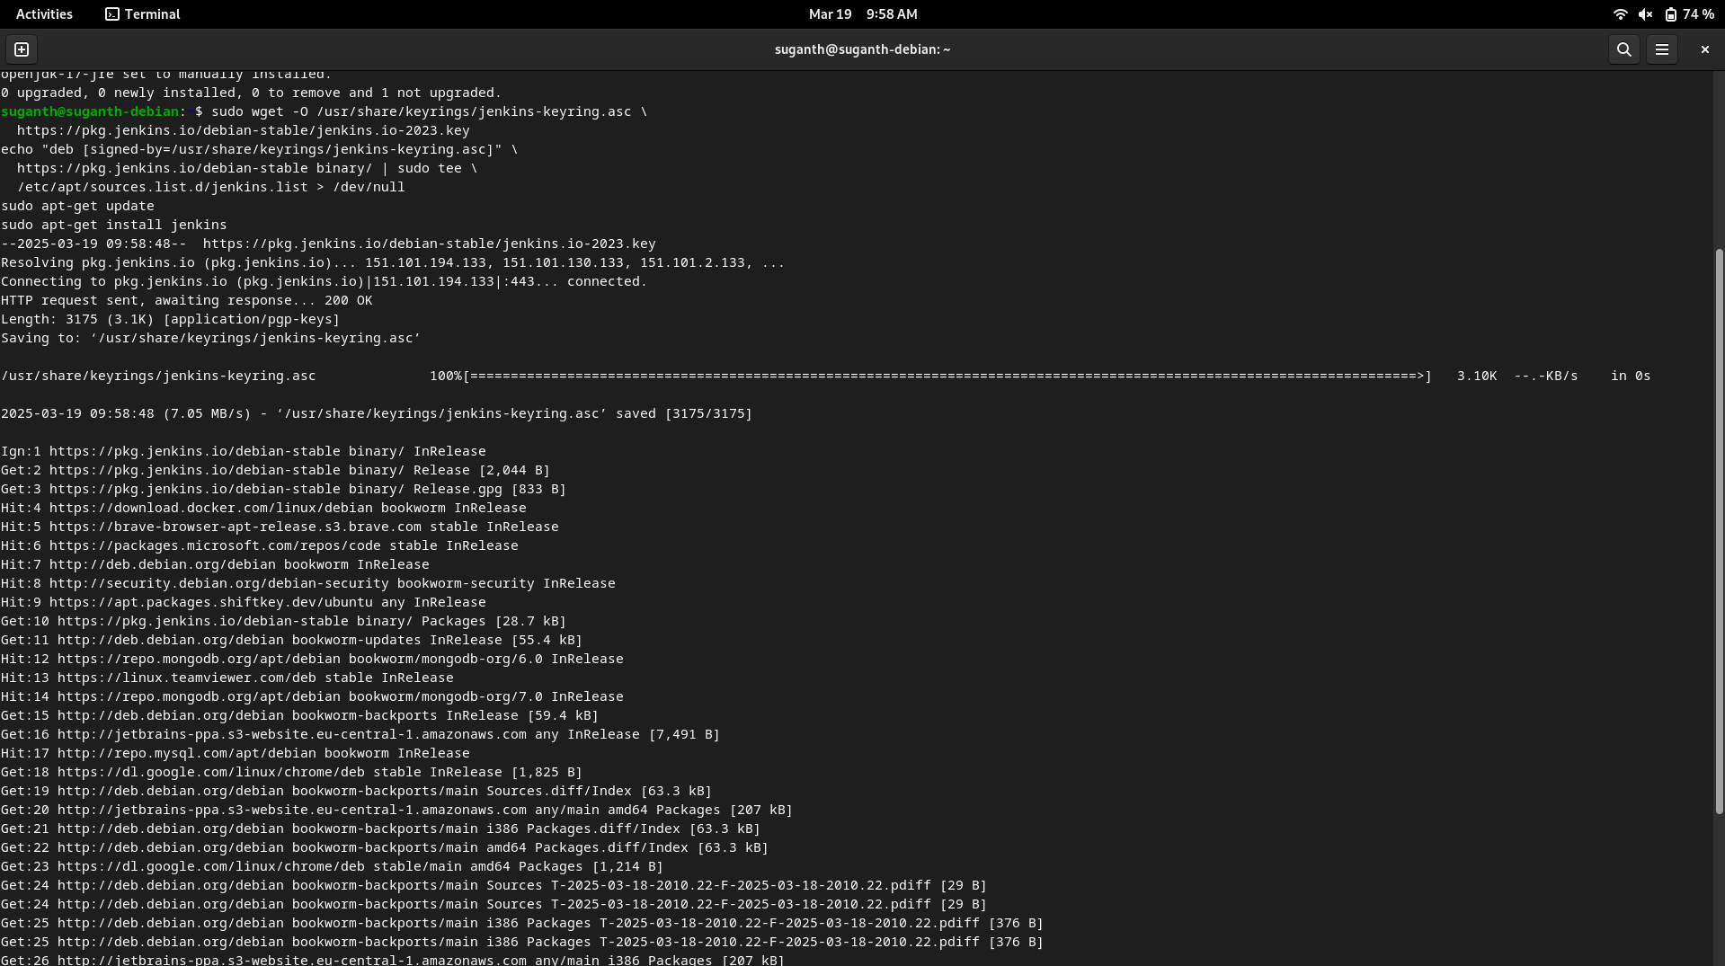
Jenkins has been successfully installed.
Now got to the Jenkins page in the browser by running localhost:8080 and login with your credentials.
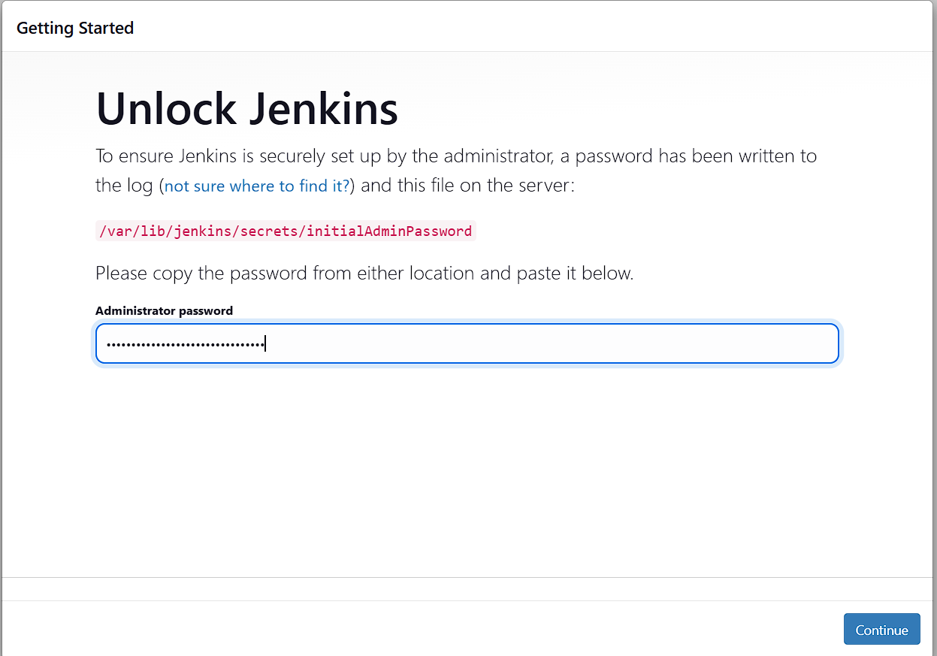

Install the Suggested plugins required and followed by Creating the First Admin User

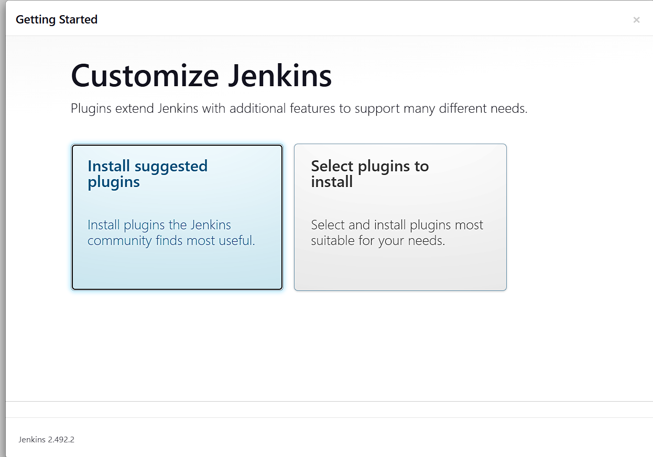

Now Jenkins is ready to use
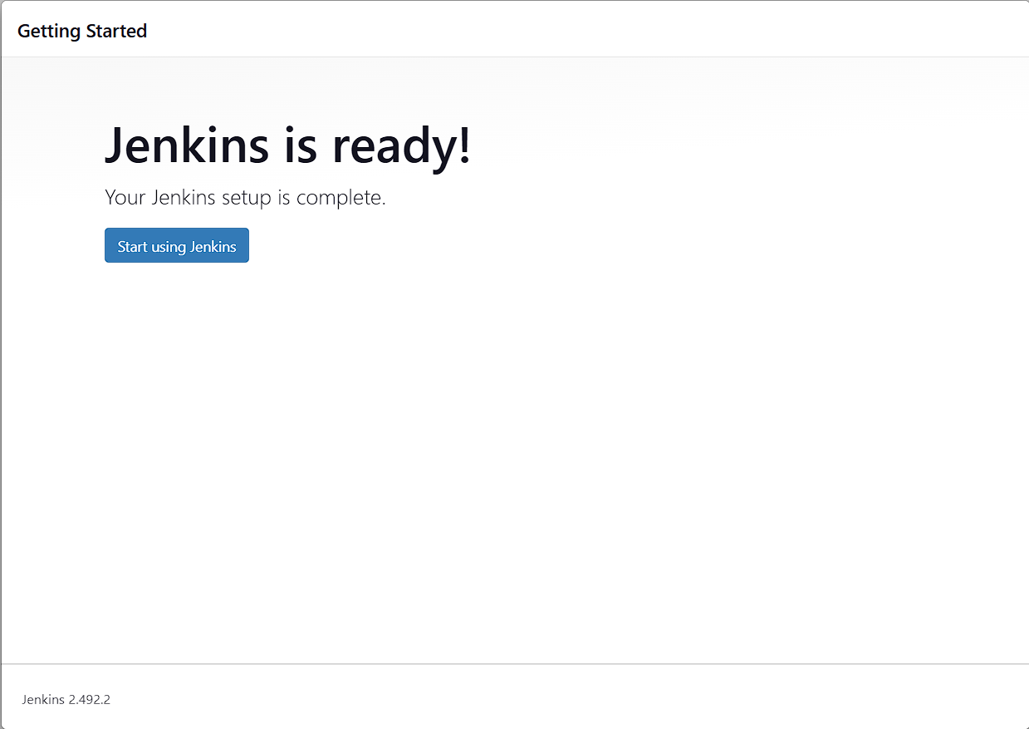

Now create a new item
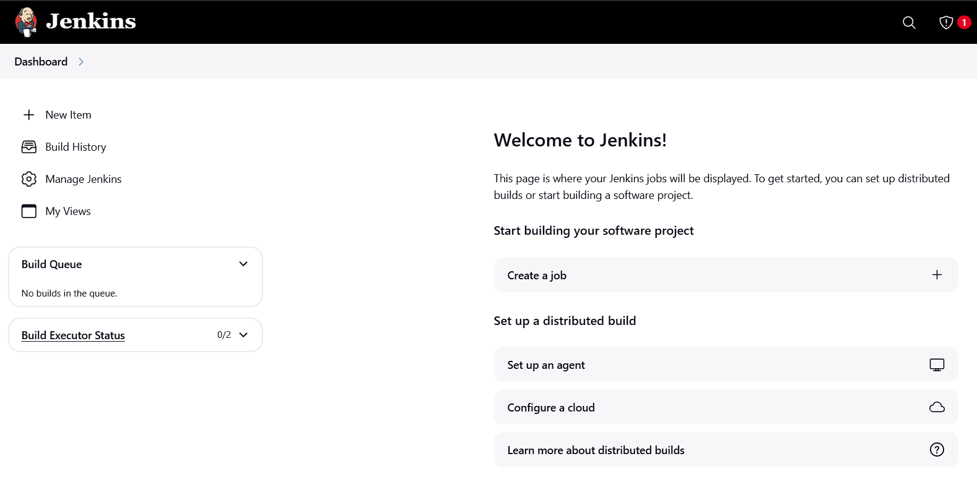

Give an item name and select the item type as free-style project
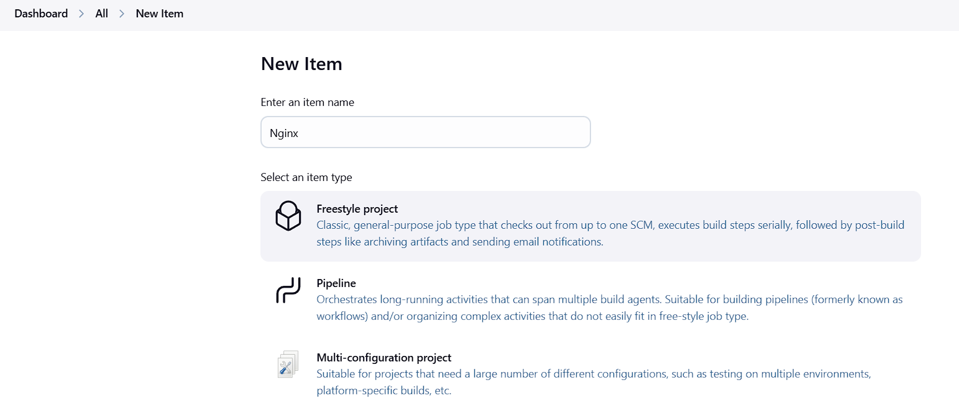

Build the steps using the commands
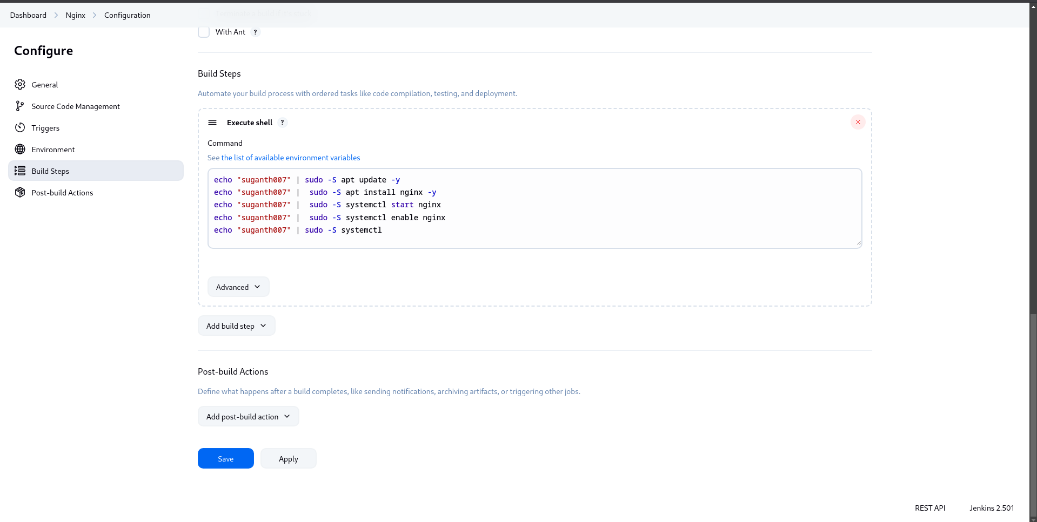

After the successful compilation of the build, Nginx will be opened in localhost, once the ip address is given
